Working in the wiki
The contents of this page are used for wiki training.

Formatting page sections

Paragraph with text formatting, images and links
A wiki (/ˈwɪki/) is an online hypertext publication collaboratively edited and managed by its own audience, using a web browser. A typical wiki contains multiple pages for the subjects or scope of the project and could be either open to the public or limited to use within an organization for maintaining its internal knowledge base.
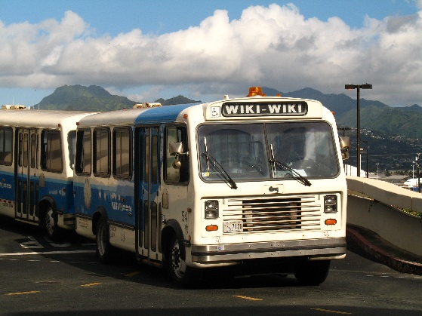
WikiWikiWeb was the first wiki. Ward Cunningham started developing WikiWikiWeb in Portland, Oregon, in 1994, and installed it on the Internet domain c2.com on March 25, 1995. It was named by Cunningham, who remembered a Honolulu International Airport counter employee telling him to take the "Wiki Wiki Shuttle" bus that runs between the airport's terminals. According to Cunningham, "I chose wiki-wiki as an alliterative substitute for 'quick' and thereby avoided naming this stuff quick-web."
Cunningham was, in part, inspired by the Apple HyperCard, which he had used. HyperCard, however, was single-user. Apple had designed a system allowing users to create virtual "card stacks" supporting links among the various cards. Cunningham developed Vannevar Bush's ideas by allowing users to "comment on and change one another's text." Cunningham says his goals were to link together people's experiences to create a new literature to document programming patterns, and to harness people's natural desire to talk and tell stories with a technology that would feel comfortable to those not used to "authoring".

Summary
- WikiWikiWeb was the first wiki
- Ward Cunnigham is the inventor of the wiki
- Working in a wiki should be easy!

Tables
Segment | Country | Sale Price | Sales | Date
Government | Canada | $ 20,00 | $ 32.370,00 | 01.01.2022
Government | Germany | $ 20,00 | $ 26.420,00 | 01.01.2022
Midmarket | France | $ 15,00 | $ 32.670,00 | 01.06.2022
Midmarket | Germany | $ 15,00 | $ 13.320,00 | 01.06.2022
Midmarket | Mexico | $ 15,00 | $ 37.050,00 | 01.06.2022
Government | Germany | $ 350,00 | $ 529.550,00 | 01.12.2022
Midmarket | Germany | $ 15,00 | $ 13.815,00 | 01.03.2022
Channel Partners | Canada | $ 12,00 | $ 30.216,00 | 01.06.2022

Flowchart
You can create flowcharts directly in the wiki.
