Procurement process

The procurement of materials largely includes the tasks of purchasing. This includes determining the order quantity, obtaining and comparing offers, placing orders, checking incoming goods and storing the goods.

Document control

Document type | Process description | Owner | <<name>>
Scope | Sales | Valid from | 31.03.2022

Process diagram

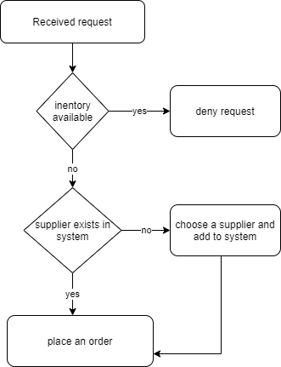

Inventory control
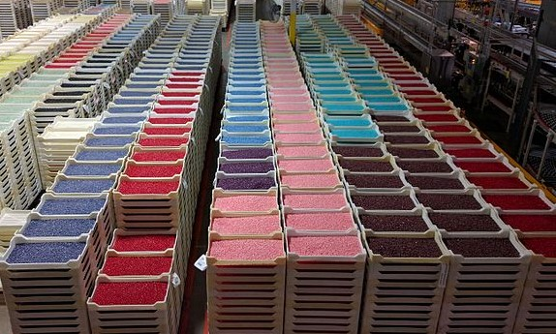
Inventory control provides a comparison of the target and actual values of stocks in the form of item master data, serial numbers and price lists. From this, important key figures are obtained about current stocks, minimum stocks, average consumption, purchase prices and planned orders.
Checklist:
- Are all material stocks, movements, receipts and withdrawals documented?
- What about retention time and turnover rate?
- How much is ordered when?
- Where are items stored in the company?
- Which items have to be counted and when?

Supplier selection
The quality of our services and products depends to a large extent on the quality of the purchased materials, products and services. For this reason, the selection of suppliers is also to be regarded as part of strategic procurement and is usually carried out in the long term in advance.

Checklist:
- What is the price and cost development of the supplier?
- What about delivery dates and adherence to schedules?
- What are the delivery terms?
- How long are the delivery times?
- Can I request samples?
- Is there a permanent contact person?
- What are the payment deadlines?
- Which payment methods are available?

Order
The PO is the formal request to a supplier to provide a product or service. If the order is placed immediately after a binding offer from a supplier and within the offer binding period, a contract is concluded directly. If the offer was non-binding, the supplier must first respond to the order with an order confirmation.

Checklist:
- Does the order contain all items, quantity and unit of measure?
- Are the delivery date and delivery address specified?
- Does the order contain all information on price, currency and payment terms?
- Is the supplier address correct?
- Has an order history been created?
- Have all return options and modalities been clarified?
- Is the supplier's customer service easily accessible at all times?

Incoming goods
Goods receipt includes the physical acceptance of the order placed. This also includes the documentation of receipt and forwarding of the objects and their input data. The value and quantity of the incoming goods must also be recorded in the accounts. These postings using the delivery notes or goods receipt invoices.
When goods are received, it is important that the delivered goods are carefully checked against the delivery note. If defects are found upon receipt of the goods, acceptance must be refused or the goods must be complained to the supplier immediately. If this does not happen, the quantity stated on the delivery note is deemed to have been delivered and is free of damage.

Checklist:
Before receiving the goods
- For whom are the goods intended?
- Does the number of packages delivered match the number on the delivery papers?
- Is there any externally visible damage to the goods?
- Was the delivery date met?
After receiving the goods
- Do the packages contain what is written on the outside?
- Do the goods show signs of damage that were not visible from the outside?

Payment processing
If the goods have been accepted, the accounting department checks the invoice as soon as it is available. The invoice should match both the order and the delivery note. If this is not the case, it is the job of accounting to eliminate these discrepancies. For this purpose, the accounting department contacts both the supplier and the purchasing department. Once everything has been clarified, the invoice is approved and posted. A payment authorization is created and the invoice amount can be paid via the bank.
Checklist:
- Do the order and the data on the delivery note match?
- Are all bank details correct?
- Have all payment steps been checked and approved?
- Is it clear where and how the invoice has to be filed?
The procurement process is completed with the payment of the invoice.

